**Alan Turing’s Impact on Technology from the Second World War to Today**

All our computers, cellphones, tablets, and almost any software running device we used in the twenty-first century share an interesting historical root, which started with the invention of the code decryption machine for the Germans’ radio frequency communication messages, during the Second World War. The Germans used a machine called Enigma to encode their messages, while the British, with the leadership of Alan Turing, started a secret project to decrypt it. The decryption of these complicated codes made it possible for the British to predict the German’s next strategic moves. Alan Turing was an English mathematician, logician, cryptanalyst, philosopher and theoretical biologist, who was born on June 23, 1912. His impact on scientific fields was not limited to building his famous machine. He is known as the father of Information Technology.[1] During his short life, he had many other scientific contributions like “LU decomposition”, which became an important concept in mathematics, and made the basement of AI by considering the question if machines can think.[2] However, all these works did not bring him an easy life. He even got arrested and sentenced, after the police learned of his sexual interest.[3] Finally, he died on June 8, 1954 by cyanide poisoning, and there are still arguments about his cause of death. However, the path he started never ended there. While Alan Turing gained his fame as the British codebreaker who developed a machine to decrypt the German Enigma-Code, his developed method of computation started a technological revolution, which formed the basis of the modern electrical computers and programming languages.

**Development of Turing Machine**

The story of Alan Turing started with publishing his paper about “Turing Machines” in 1936. Around the same time, another paper was published in the same field, by the American logician Alonzo Church. Following that Turing spent two years studying for his Ph.D. at Princeton University, under Church[4]. During this time, the idea of his machine broadened even more, and also, he built three of the four electromechanical binary multipliers, which later helped the development of electrical computers. Then he started his study on cryptography.

**Turing Machine and the Second World War**

His research and experiences in cryptography were followed by an invitation from the British government in 1939, to work on a top-secret project. He returned to England, where they announced the details of the project.4 The idea of the government was to bring the top mathematicians together as a team, to decrypt the code. It did not take long until Turing proved that it was almost impossible to break the code in a reasonable time, so the broken code would be valueless by the time that it was done. This was a big shock for the British government.

But Turing also suggested a solution, which could bring some hope. He explained that the original process of decryption by mathematicians can be listed in a set of calculation and decision steps. Then each of those steps can be broken into even smaller steps, and continue this until the problem is just a long list of very simple decisions and calculations on one or multiple long tapes.[5] This tape would provide access to all small calculation steps in the system, and by adding a location pointer to this tape, it would be possible to move the pointer to any particularly predetermined subproblem and solve it for any given input. While this tape was a mechanical piece in Turing’s machine, the same idea is used in modern computer memories by running a software.[6]

The idea seemed to be simple, but implementing an untested machine for a complicated project with unknown dimensions was a big risk, and time was scarce during the war. However, this was the only hope, so they decided to replace the mathematicians, with this intelligent mechanical machine. This could accept an input, and check all the cryptography possibilities, until finding a meaningful solution for it. The machine could eliminate the human mistakes, and speed up the process at the same time.

**Problems During the Development**

The progress was in an unknown state until they cracked the first code successfully. The project team with the leadership of Alan Turing started to design and build the decryption machine, but there were too many aspects, and too many details to cover. Even though the team was composed of the best mathematicians, they still were not close to his level of knowledge and problem analysis. These problems made it so hard for him to provide an exact finishing time for the project. In one of the “most-secret” letters signed by Turing in November 1939, he mentioned “there is now an extremely good chance of solving these messages on a smaller machine than that now under construction[7]”. In the second appendix to the same letter, he mentioned “With the rack we shall, in such cases, almost certainly be able to solve 40% of the messages, and probably 70%. If by that time we are able to apply Method (i) as well, we may be able to solve as many as 200 messages on that day. If this ever happens it will be possible to solve the indicating system7”. This clearly shows that at the time of writing the letter they thought they were so close to successfully decrypting the code, but the first complete code was not successfully decrypted until the spring of 1940.1

**Impacts on the Second World War**

Despite all those problems the project succeeded, and this was one of the most important moments during the Second World War. The German military assumed that Enigma code was simply unbreakable, or there wouldn’t be enough time to break it, and this secret project made the Atlantic safe for the British. This was a big advantage, and according to the New York Times, Winston Churchill admitted the U-boat menace was his biggest fear[8], and this decryption solved that issue. The other outcome of this decryption was that it made it possible for the allies to read what Hitler and his generals were saying.

**Artificial Intelligence Born**

After the war, he continued improving his machine, and he developed two of the first modern computers[9], and became the first serious user of an electronic computer for mathematical research. These developments were followed by publishing another famous paper called “Computing Machinery and Intelligence”2, in 1950. This paper tied mathematics, logic, and computation models, and established a new filed, which later was called Artificial Intelligence. This paper still is a big source of information for computer scientists who are studying AI. He also introduced this idea to the field experts in September of that year in “Conference on Information theory”, where he explained that a machine can alter its own structure, and learn during the progress. He also expanded some other new concepts for the first time, like Random-Search, which would now be called genetic algorithms.[10]

**Turing’s Demise**

Despite all his work, the government of the time didn’t show him enough gratitude. Rather he received lots of unkindness from the society, just because he was gay. As the report3 below shows, he was arrested and sentenced in March 1952, because of sexual interest and his sexual relationship with a young Manchester man. The court left him with only two choices: prison or chemical castration by series of female hormone injections1. He didn’t think that he could stand prison, so he picked the second choice, which led him to a depression. This was a point for the last two years of his life, and he didn’t do any big publishes during those years. Finally, his valuable life came to the end, by a cyanide-poisoned apple. There are still arguments about whether it was really a suicide, a mistake, or a planned murder trap. His body was found by his housekeeper a day after his death, on June 8, 1954, 14 days before his forty-second birthday1.

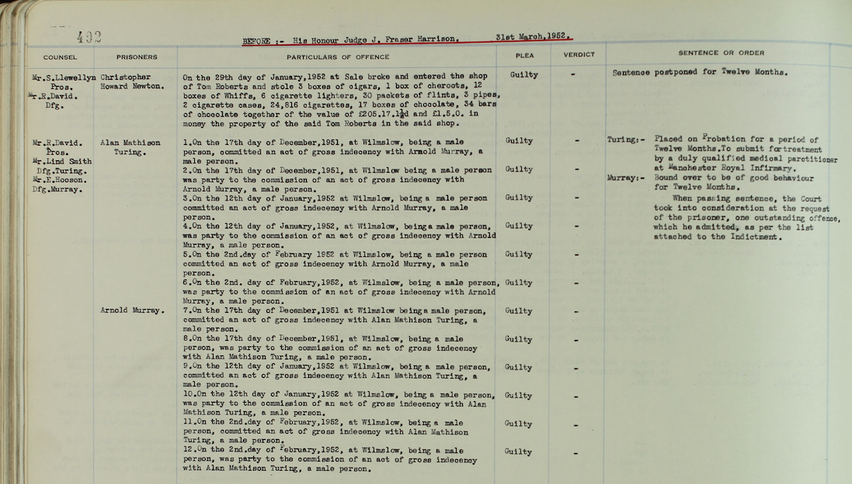 Turing’s Court Report

However, even the last years of his life, made a positive impact on the society, by making people think about how to accept and welcome minorities, and specifically gays. Fifty-five years later in 2009, Britain’s Guardian newspaper published an article which stated an apology by the Britain’s prime minister Mr. Gordon Brown, on behalf of the British Government for what they had done to Turing. He mentioned, “we can’t put the clock back, his treatment was of course utterly unfair, and I am pleased to have a chance to say how deeply sorry I and we all are for what happened to him”.1

**Machines Could think**

It didn’t take much longer until Turing’s question of if machines can think became a serious concept of design for logicians. In 1936, Alonzo Church stated his thesis, which proved any process on natural numbers, which is computable by an algorithm written by a human being can be also computable by Turing’s model.[11] Churches thesis showed that it is possible to have a machine with a known set of steps, which can apply them to any valid input, and return a result.

In 1941, Churches idea got improved and implemented, by a German civil engineer named Konrad Zuse. His designed a machine was called Z3, and it could do specific calculations, and in 1945 he developed Z4, the first universal computer.1 Zuse opened a new window by making it possible to have a programmable computer.

**Programming Languages**

Turing’s algorithm became the basement of modern programming languages. Zuse’s system is known to be the first high-level programming language. However, his programming language was never implemented in software level, until recently in 1998. Later, many other programming languages were designed and developed, and Turing’s algorithm is still one of two major methods of programming language design. Some of the most well-known Turing based programming languages: Turing, Pascal, Java, C++, and almost every other object-oriented modern language.

**Conclusion**

Alan Turing made a huge impact on the Second World War and building the modern computers. His work was continued by other mathematicians, and logicians to expand his work and develop new technologies. The computation model that he designed more than eighty years ago, is the pattern behind many current programming languages. His brilliant work made it possible for us to type and view our texts, surf websites, and take or view our favorite images, as simple as we can do these days.

Bibliography

"Alan Turing's trial." Alan Turing's Trial. March 31, 1952. Accessed October 24, 2017. http://www.turing.org.uk/sources/sentence.html.

Bernhardt, Chris. 2016. Turing's Vision: The Birth of Computer Science. Cambridge, Mass.: MIT Press. Accessed November 18, 2017. ProQuest Ebook Central.

Company (2017). World War II’s Greatest Hero: The True Story of Alan Turing (Paid Post by The Weinstein Company From NYTimes.com). [online] Paidpost.nytimes.com. Available at: https://paidpost.nytimes.com/the-weinstein-company/world-war-iis-greatest-hero-the-true-story-of-alan-turing.html [Accessed 17 Nov. 2017].

Copeland, B. Jack. Turing: Pioneer of the Information Age. Oxford: Oxford University Press, 2012. Accessed October 9, 2017. ProQuest Ebook Central.

DiSalvo, D. (2012). How Alan Turing Helped Win WWII And Was Thanked With Criminal Prosecution For Being Gay. [online] Forbes. Available at: https://www.forbes.com/sites/daviddisalvo/2012/05/27/how-alan-turing-helped-win-wwii-and-was-thanked-with-criminal-prosecution-for-being-gay/#1c4040525cc3 [Accessed 17 Nov. 2017].

Gherardi, Guido. "ALAN TURING AND THE FOUNDATIONS OF COMPUTABLE ANALYSIS." The Bulletin of Symbolic Logic 17, no. 3 (2011): 394-430. http://www.jstor.org/stable/41228533.

Marion, Jean-Yves. "From Turing Machines to Computer Viruses." Philosophical Transactions: Mathematical, Physical and Engineering Sciences 370, no. 1971 (2012): 3319-339. <http://www.jstor.org/stable/23250190>.

Mathworks.com. (2017). Alan Turing and His Connections to MATLAB. [online] Available at: https://www.mathworks.com/company/newsletters/articles/alan-turing-and-his-connections-to-matlab.html [Accessed 17 Nov. 2017].

Turing, A. M. "Computing Machinery and Intelligence." Mind 59, no. 236 (1950): 433-60. http://www.jstor.org/stable/2251299.

Turing, Alan M. "Conference on Information theory, 26-29 September 1950." Conference on Information Theory, London 1950. Accessed October 24, 2017. http://www.turing.org.uk/sources/info50turing.html.

Turing, Alan. "Report on Enigma decipherment." Enigma report, November 1939. Accessed October 24, 2017. http://www.turing.org.uk/sources/nov39.html.

1. Copeland, B. Jack. *Turing: Pioneer of the Information Age*. Oxford: Oxford University Press, 2012. Accessed October 9, 2017. ProQuest Ebook Central.
2. Turing, A. M. *"Computing Machinery and Intelligence."* Mind 59, no. 236 (1950): 433-60. http://www.jstor.org/stable/2251299.
3. *"Alan Turing's trial."* Alan Turing's Trial. March 31, 1952. Accessed October 24, 2017. http://www.turing.org.uk/sources/sentence.html.
4. Mathworks.com. (2017). Alan Turing and His Connections to MATLAB. [online] Available at: https://www.mathworks.com/company/newsletters/articles/alan-turing-and-his-connections-to-matlab.html [Accessed 17 Nov. 2017].
5. Gherardi, Guido. "ALAN TURING AND THE FOUNDATIONS OF COMPUTABLE ANALYSIS." The Bulletin of Symbolic Logic 17, no. 3 (2011): 394-430. http://www.jstor.org/stable/41228533.
6. Marion, Jean-Yves. "From Turing Machines to Computer Viruses." Philosophical Transactions: Mathematical, Physical and Engineering Sciences 370, no. 1971 (2012): 3319-339. http://www.jstor.org/stable/23250190.
7. Turing, Alan. "Report on Enigma decipherment." Enigma report, November 1939. Accessed October 24, 2017. http://www.turing.org.uk/sources/nov39.html.
8. Company (2017). World War II’s Greatest Hero: The True Story of Alan Turing (Paid Post by The Weinstein Company From NYTimes.com). [online] Paidpost.nytimes.com. Available at: https://paidpost.nytimes.com/the-weinstein-company/world-war-iis-greatest-hero-the-true-story-of-alan-turing.html [Accessed 17 Nov. 2017].
9. DiSalvo, D. (2012). How Alan Turing Helped Win WWII And Was Thanked With Criminal Prosecution For Being Gay. [online] Forbes. Available at: https://www.forbes.com/sites/daviddisalvo/2012/05/27/how-alan-turing-helped-win-wwii-and-was-thanked-with-criminal-prosecution-for-being-gay/#1c4040525cc3 [Accessed 17 Nov. 2017].
10. Turing, Alan M. "Conference on Information theory, 26-29 September 1950." Conference on Information Theory, London 1950. Accessed October 24, 2017. http://www.turing.org.uk/sources/info50turing.html.
11. Bernhardt, Chris. 2016. Turing's Vision: The Birth of Computer Science. Cambridge, Mass.: MIT Press. Accessed November 18, 2017. ProQuest Ebook Central.